RESTRICTING AND SORTING DATA
1.Employee Earning More than 12,000
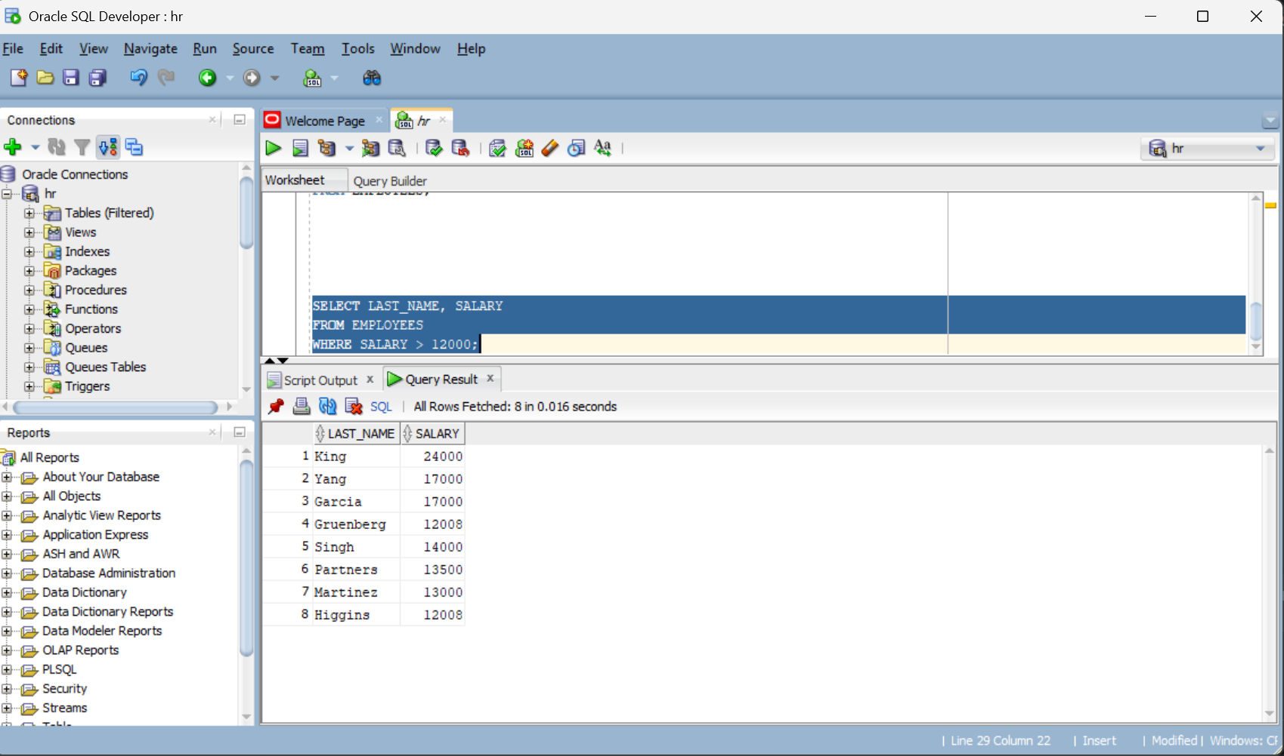

2.Employee 176 Details
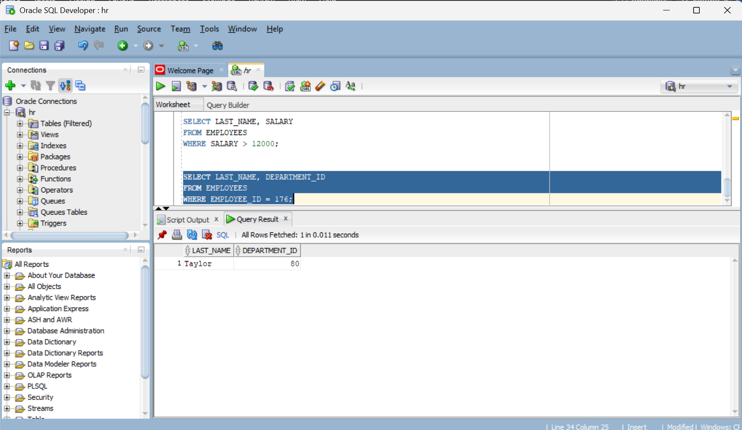

3.Salary OutSide the Range $5000- $12000
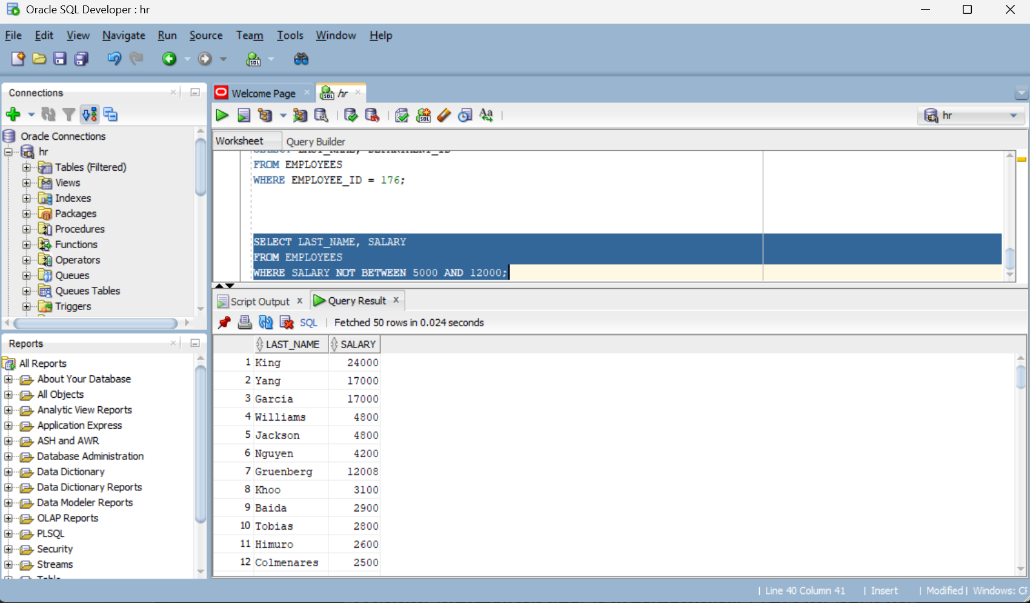

4.Details of Employees Named Taylor and Matos
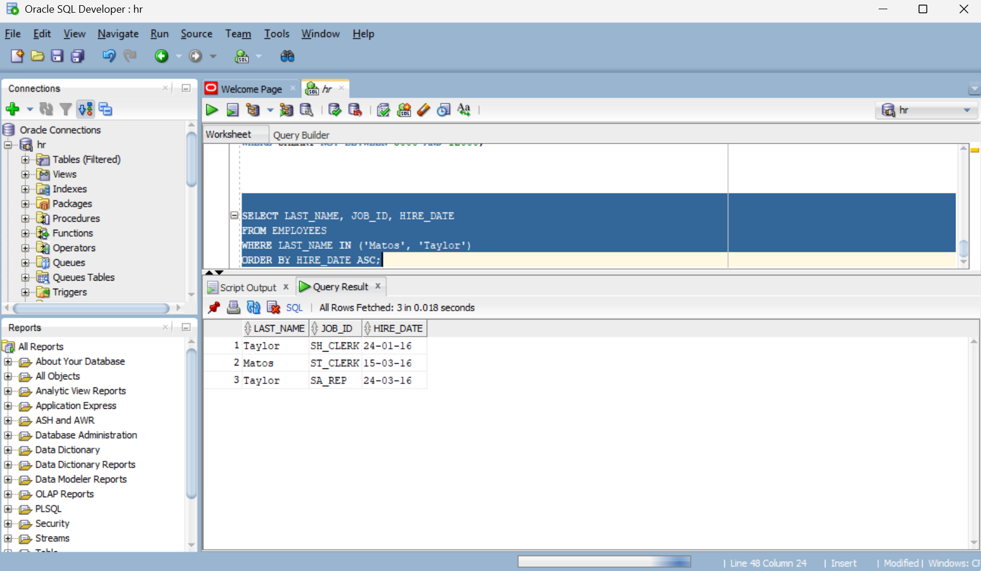

5.Employee Details in Departments 20 or 50
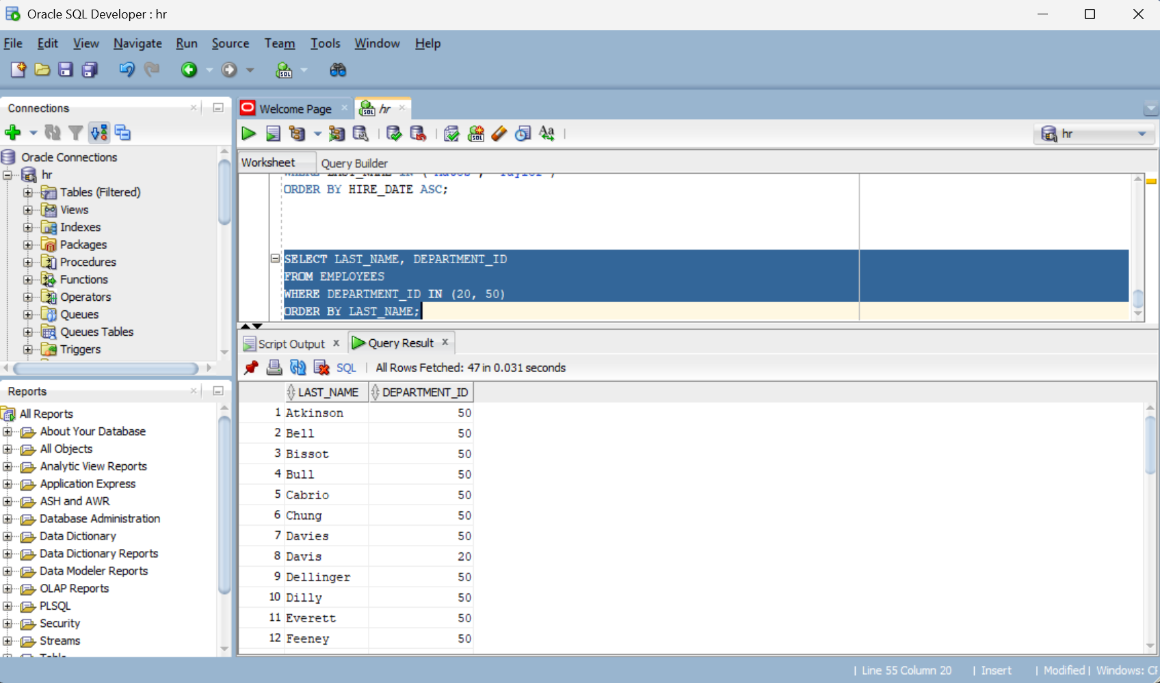

6.Employees With Salary Between $5000 and $12000
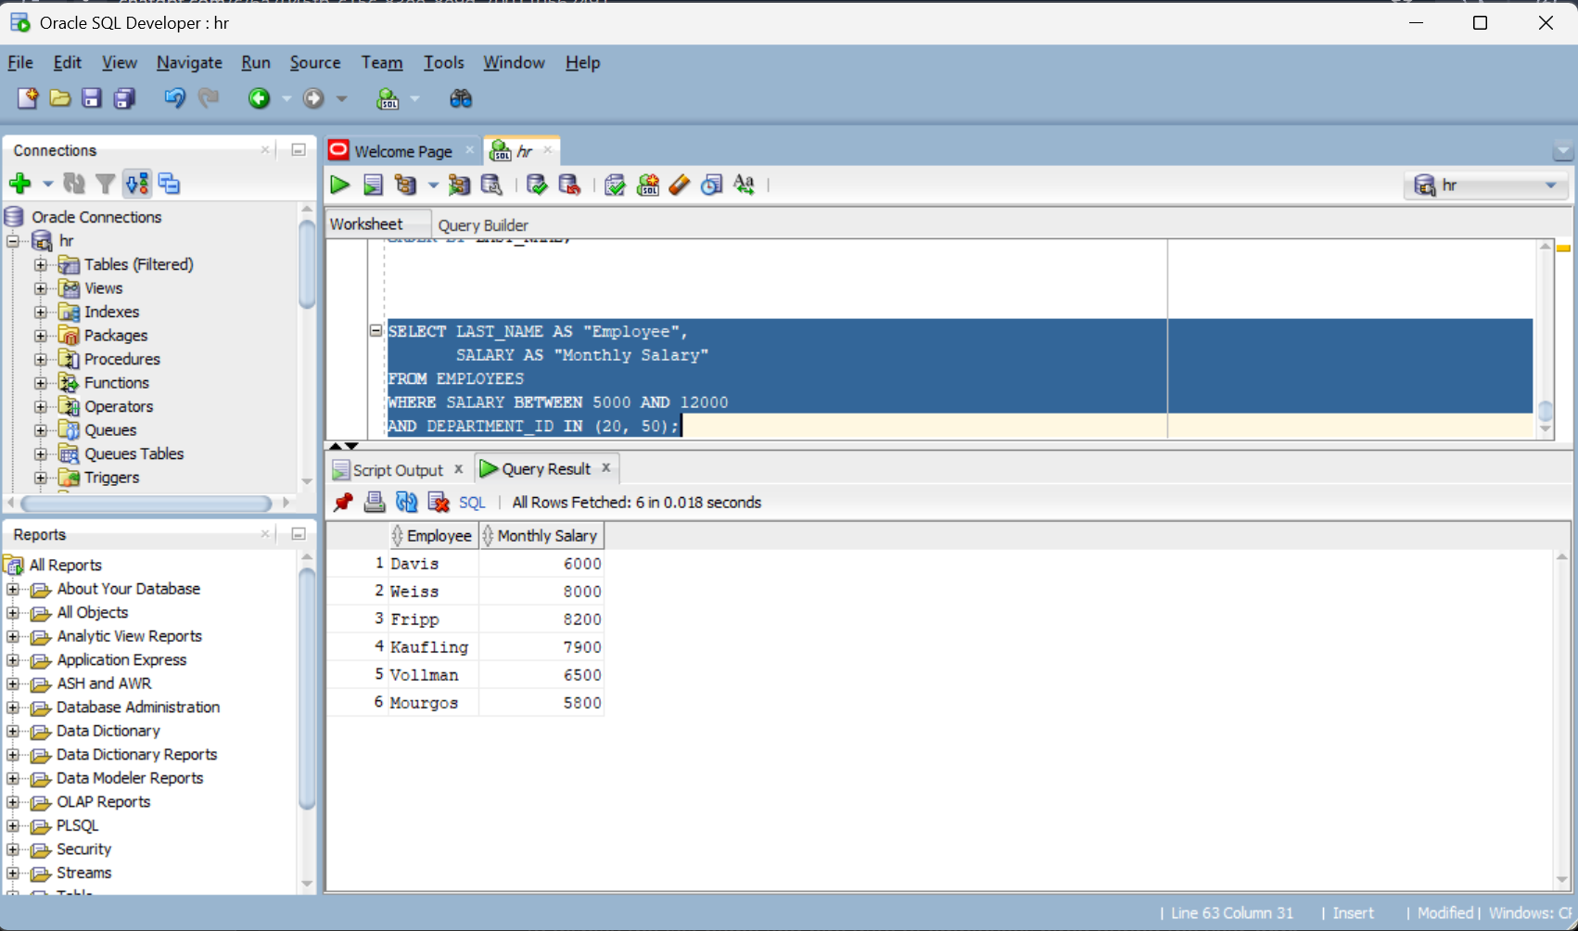

7.Display Employees Hired in 1994
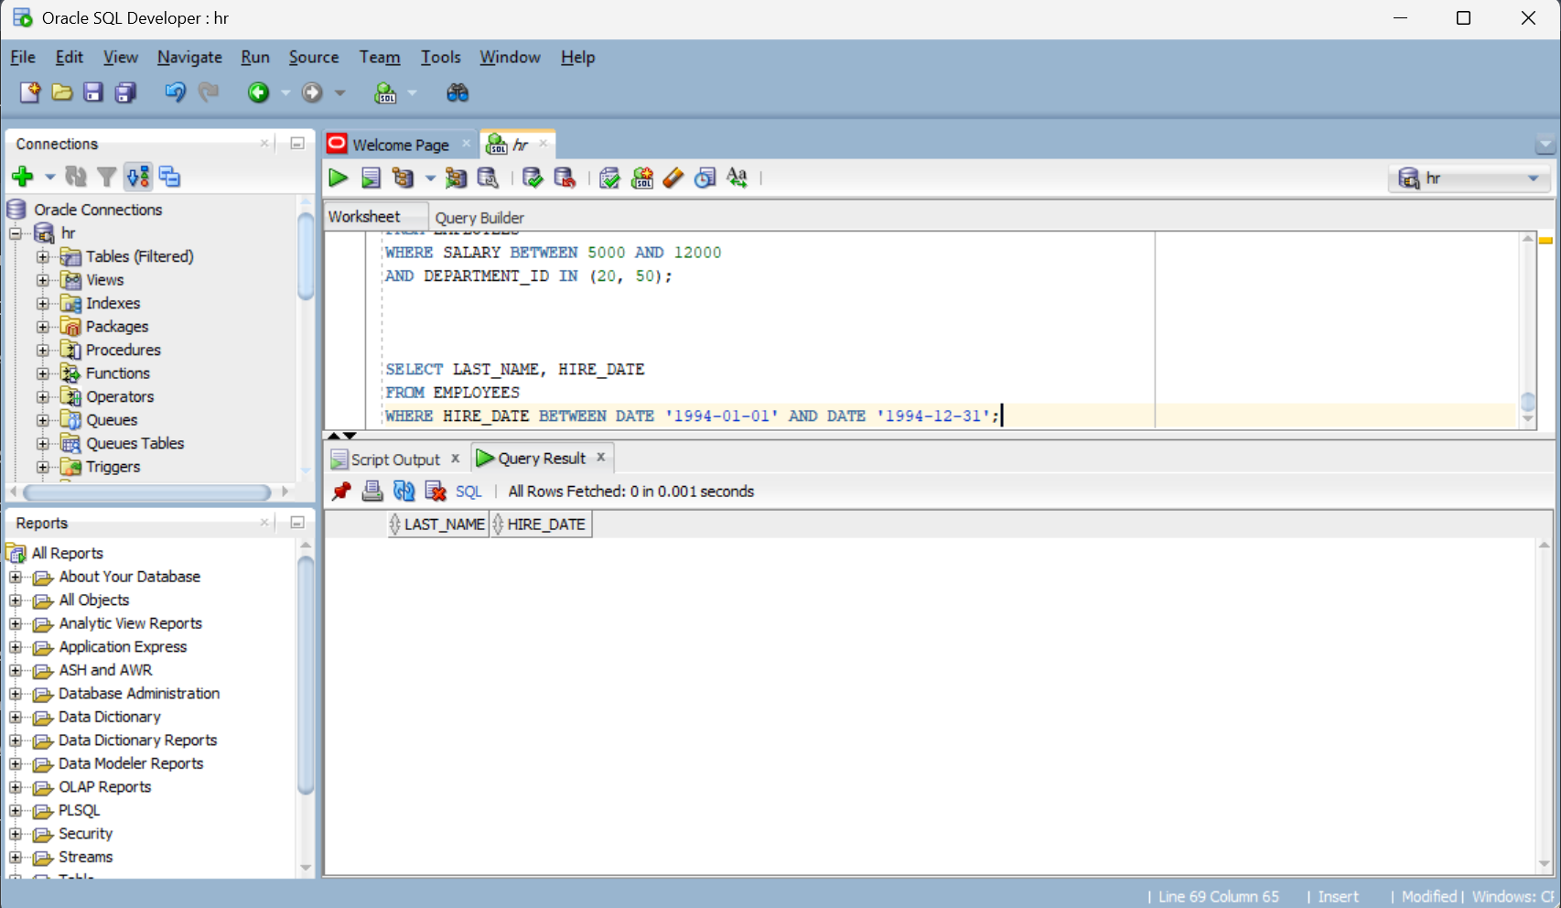

8.Display Employees Without a Manager
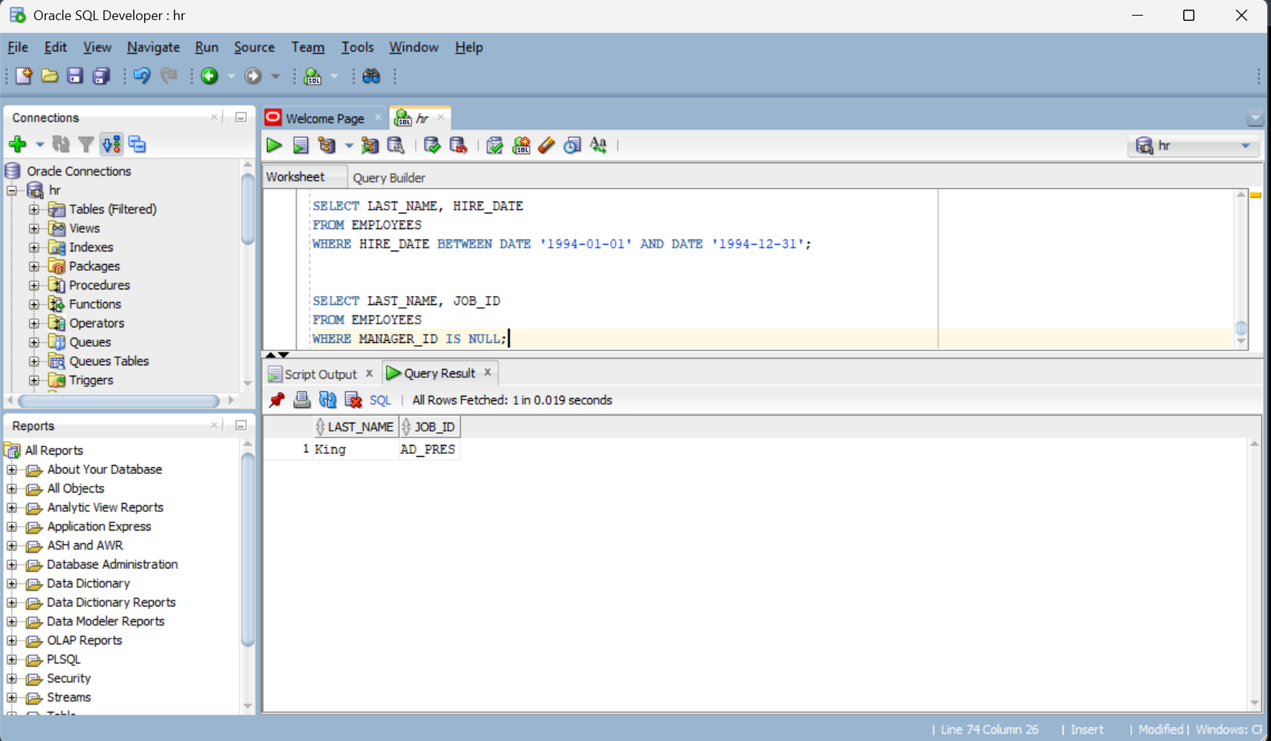

9.Employees who Earn Commission
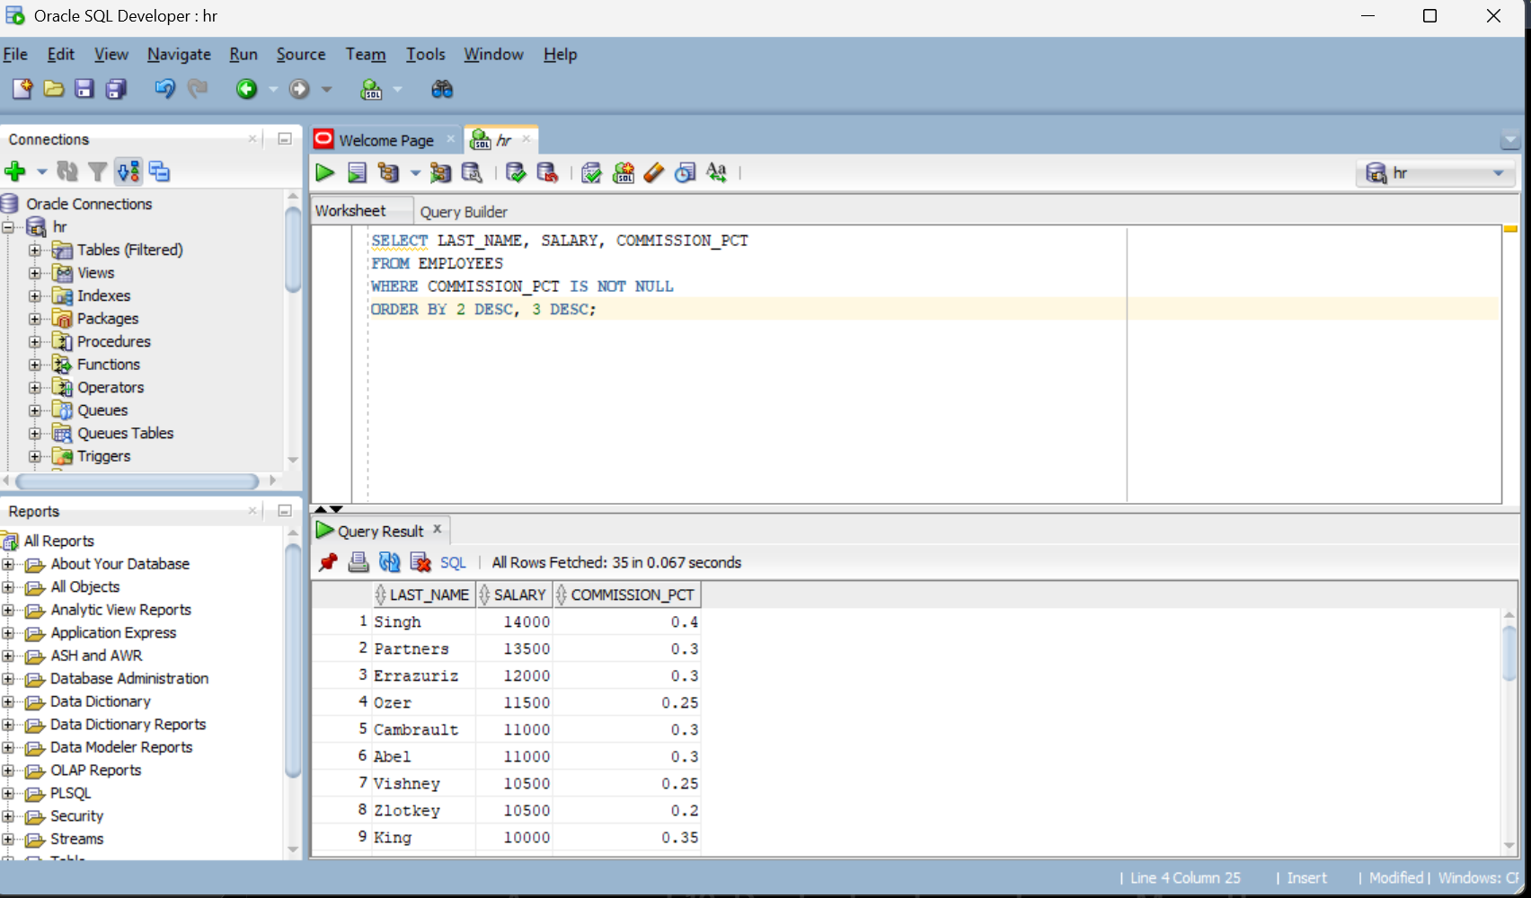

10.Employees Earning more than a User – Specified Salary
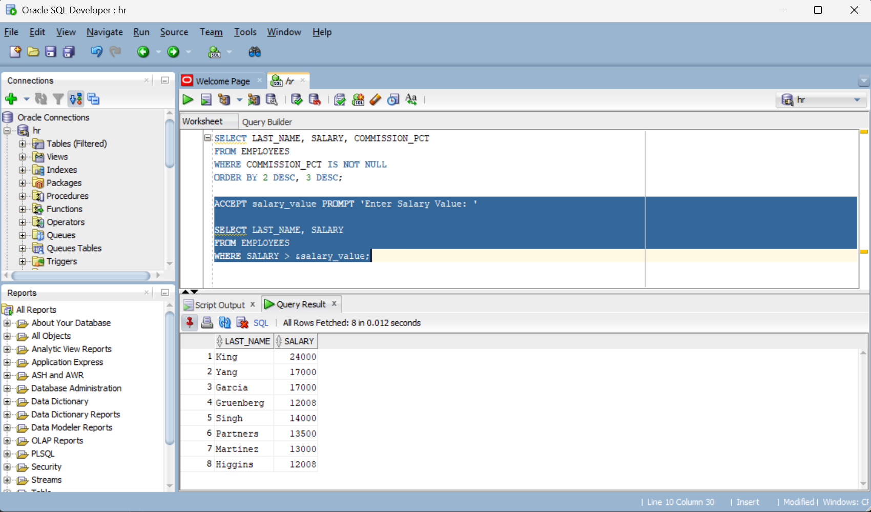

11.Employees Reporting to a Manager
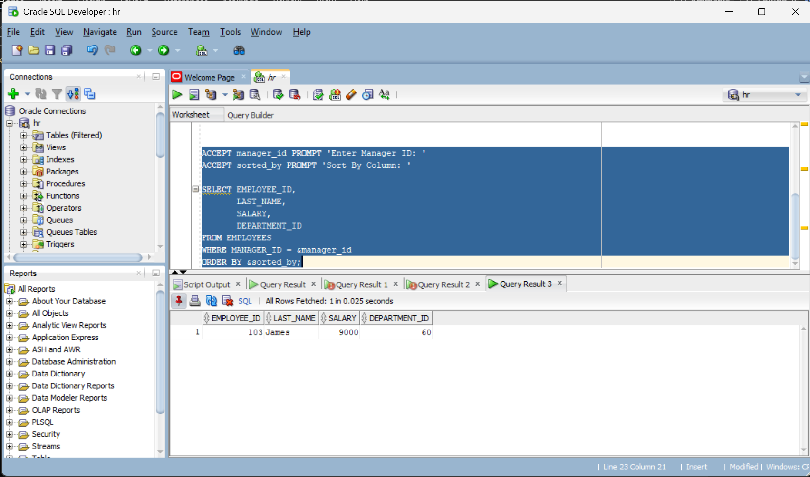

12.Employees Whose Third Letter is ‘a’
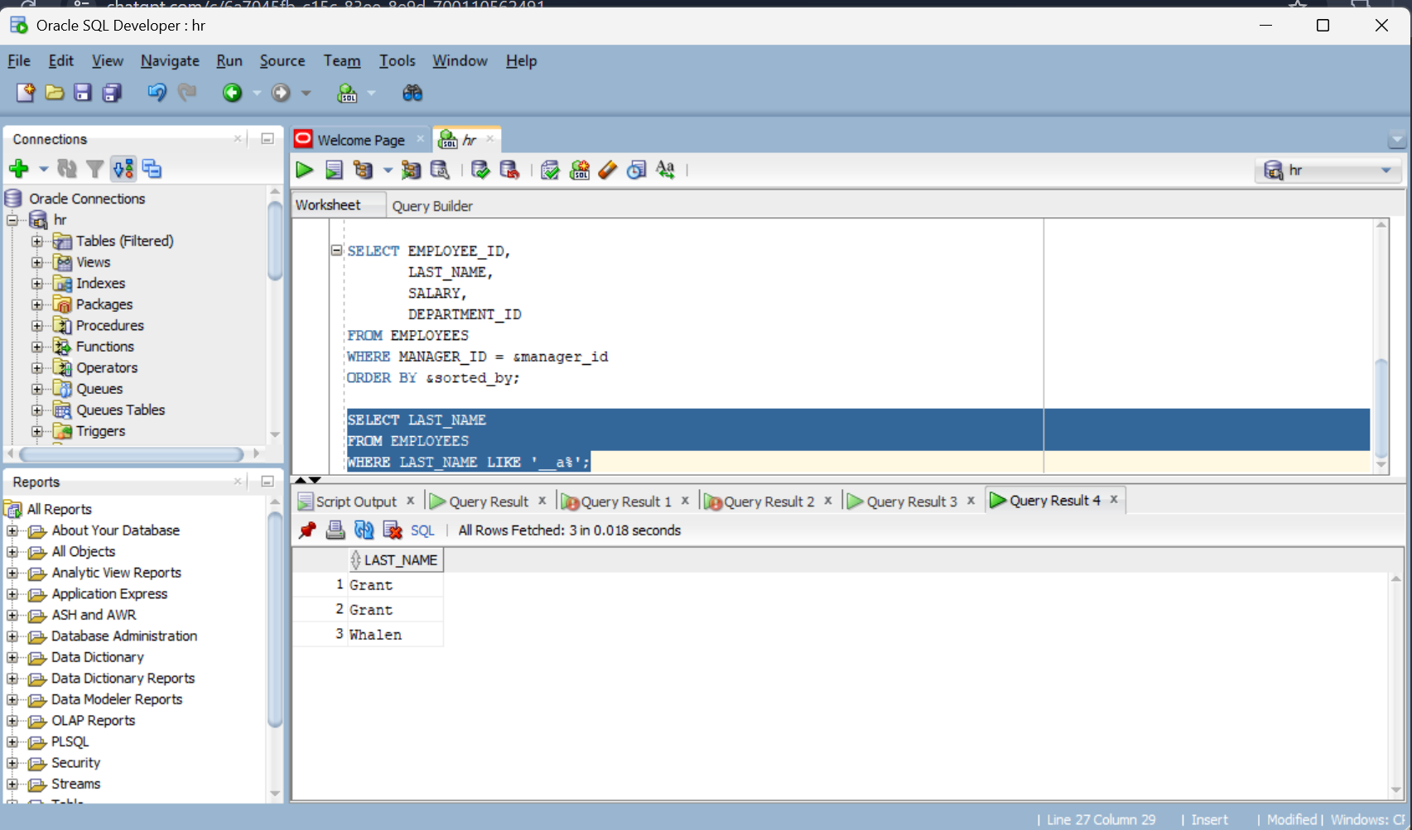

13.Employees Having both ‘a’ and ‘e’ in their Last Name
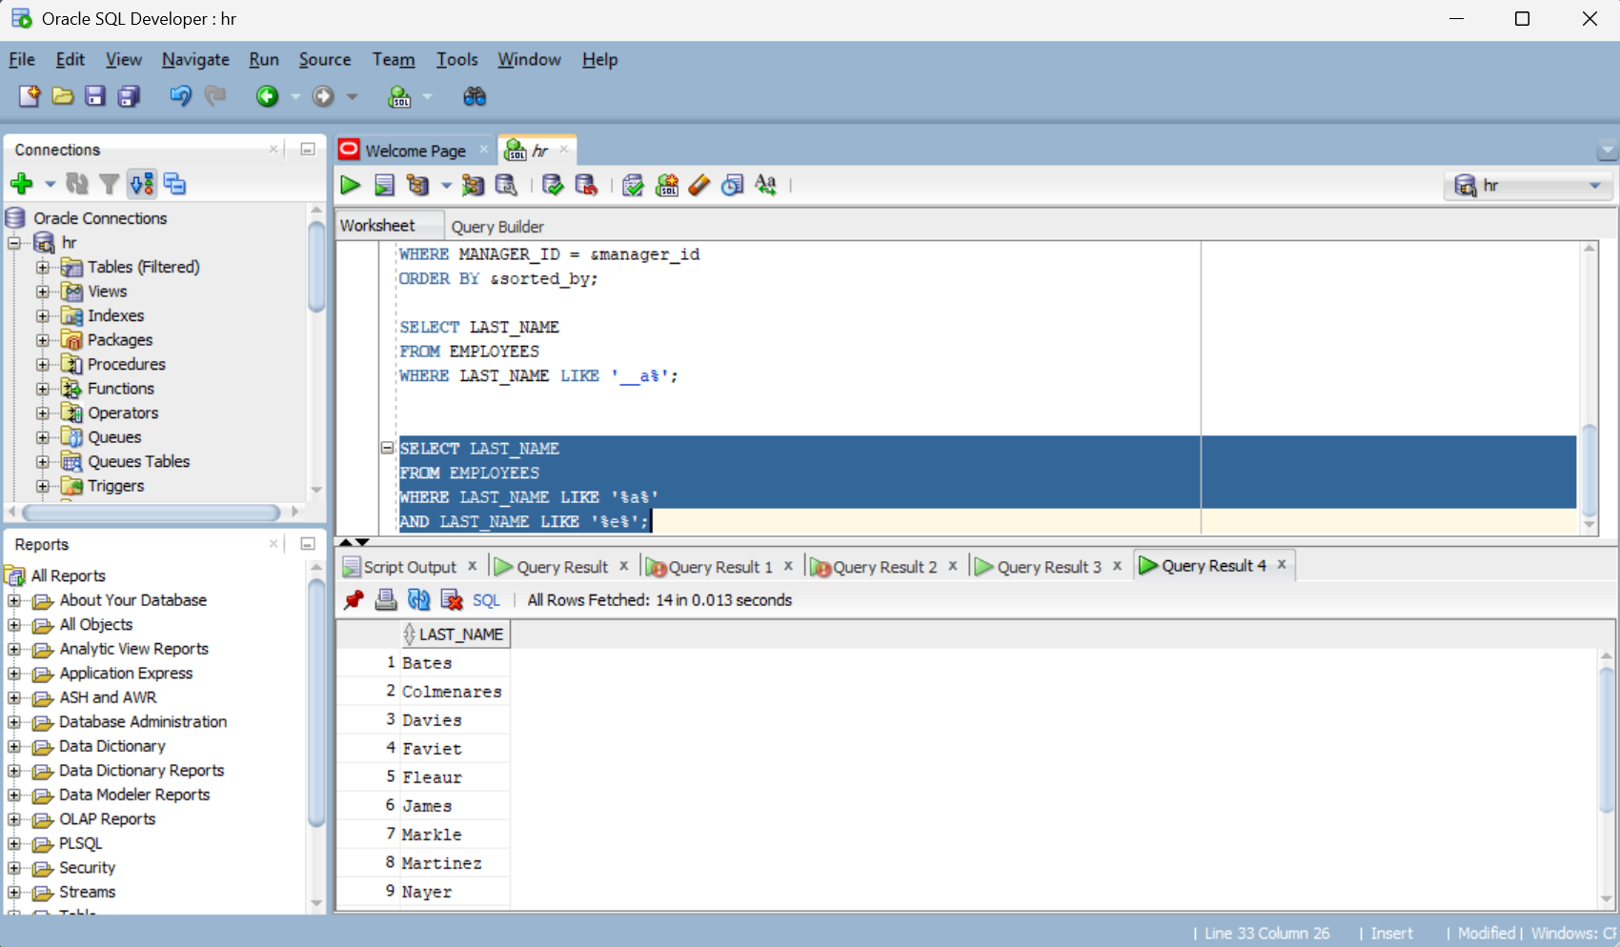

14.Display Sales Representatives and Stock Clerks
